# PlanetarySystemLRGBAligner for the automatic creation of LRGB composites of the moon and planets

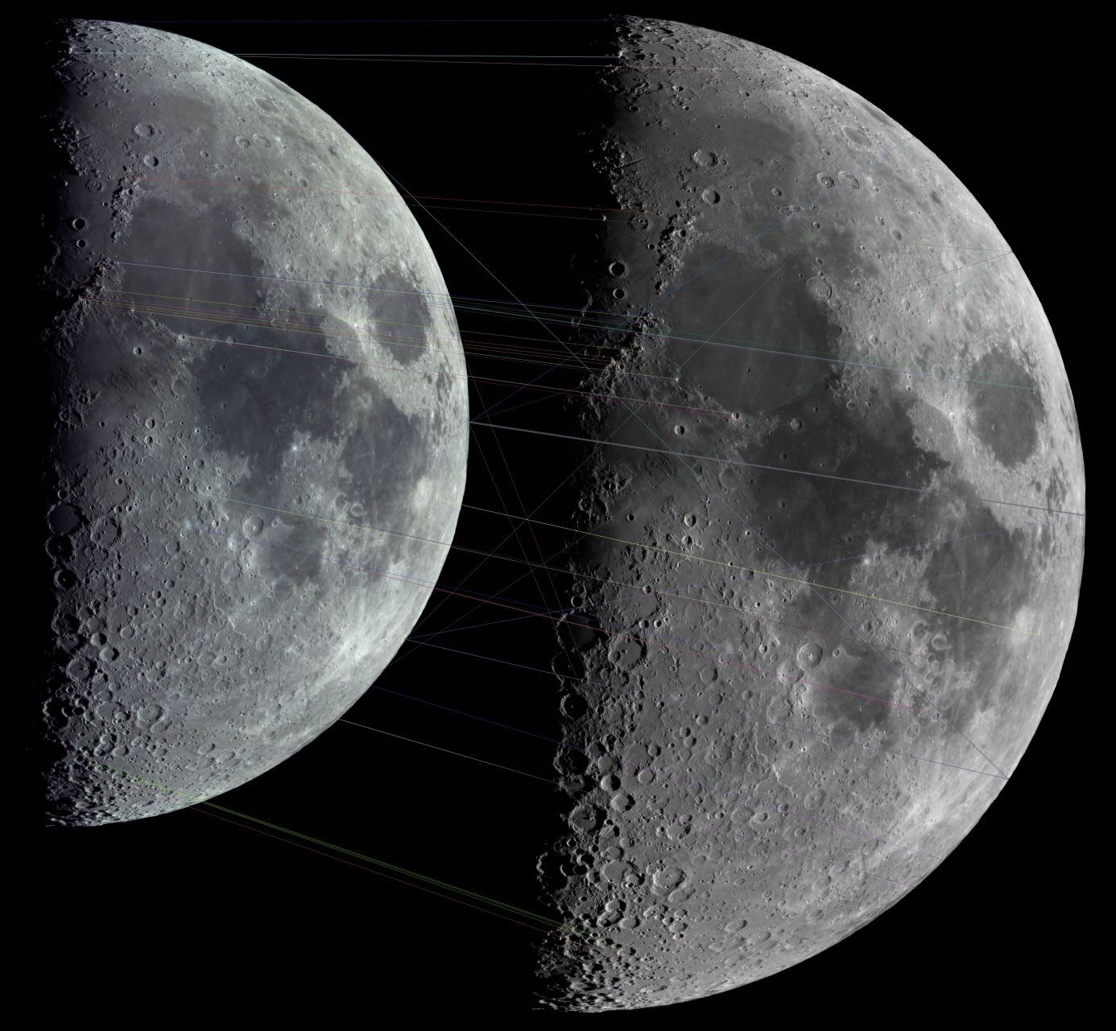

March 24, 2018. Celestron 11, Color (ASI178MC) and B/W (ASI120MM-S) panoramas and keypoint matches. © Rolf Hempel, 2018

## 

## User Guide (Version 0.5.0, Nov. 13, 2018)

Rolf Hempel

#### *Table of Contents*

1. Introduction 2

2. Changelog 3

2.1 First published version: 0.5.0 (November 2018) 3

3. System Requirements and Software Installation 3

3.1 Windows (7 / 8 / 10) 3

4. Program Execution 3

4.1 Layout of the Main Window 4

4.2 Loading input images 5

4.3 The configuration dialog 5

4.4 Starting the registration process 7

4.5 Inspecting the registration quality 7

4.6 What if the registration failed? 8

4.7 LRGB image composition 11

4.8 Saving the resulting images 11

## Introduction

Imaging of planetary system objects, such as the Moon or planets, at high magnification suffers from the degrading effect of the Earth's atmosphere. Since the effect grows with decreasing wavelength, images are sharpest if taken through red or infrared filters. Color images, on the other hand, suffer from strong seeing effects at shorter wavelengths.

By combining a sharp B/W image taken in the near infrared with a color image with much less resolution, the LRGB technique has the potential to create a color image with the full resolution of the near-infrared image. Technically, the B/W image is assigned to the "luminance" channel of the combined image, while the color image's RGB channels only provide the color information.

For this to work properly, both images first have to be registered pixel-wise with high precision. For extended objects such as the moon, this requires more than a simple affine mapping. Instead, it is necessary to perform a local warping of the color image across the whole image to match it with the B/W one. This cannot be done manually by using a standard image processing program.

PlanetarySystemLRGBAligner does this image registration automatically using a two phase approach: First, it computes a rigid homography mapping to match the color image approximately with the B/W image. In a second phase, an "optical flow" algorithm adjusts the registration of both images at every pixel location.

## Changelog



### First published version: 0.5.0 (November 2018)

* Fully operational software for Windows 10

## System Requirements and Software Installation

PlanetarySystemLRGBAligner is written in Python 3.5 and uses standard Python libraries only. It should, therefore, run on any operating system where this Python version is available. So far, however, an automatic installer has been built for Windows only. If users want to run the program on other platforms, they can download the source code from the Github repository and execute the file “planetary_system_LRGB_aligner.py” with the Python 3.5 interpreter.



### Windows (7 / 8 / 10)

The PlanetarySystemLRGBAligner software is distributed as a single file: the Windows installer [“PlanetarySystemLRGBAligner_V0.5.0_Windows-Installer.exe”](https://github.com/Rolf-Hempel/MoonPanoramaMaker/releases). Before installation, any earlier PlanetarySystemLRGBAligner version should be de-installed first using the “Uninstall” entry in the program menu. When the installer is started, a wizard guides the user through the installation process. Apart from the program start entries, PlanetarySystemLRGBAligner does not write any parameters into the Windows Registry and can be installed at any file system location. An uninstaller is provided with the software. It removes all installed files.

The Windows installation wizard offers to place a program starter on the desktop. It is decorated with the PlanetarySystemLRGBAligner icon automatically, which can be found under the filename “PlanetarySystemLRGBAligner.ico” in the installation folder.

The whole software was developed on an Acer laptop computer (type “Acer Aspire V5-573G”, Intel Core i5-4200U, 12 GBytes RAM) running Windows 10 Professional, version 1803. It was tested successfully on a Windows 7 system as well.

## Program Execution

PlanetarySystemLRGBAligner communicates with the user via a graphical user interface (GUI). The GUI delegates all computations to a separate “workflow” thread. It, therefore, stays fully responsive even if a long-running computation is going on in the background.



### Layout of the Main Window

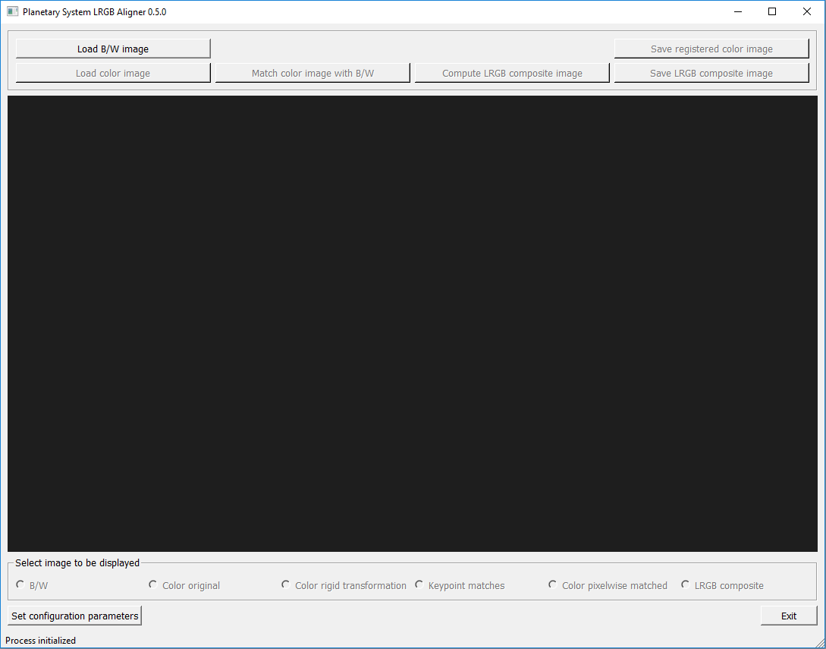

The main window contains five sections (from top to bottom):

* The control section contains buttons to start the various program functions. If at a given time a function does not make sense or cannot be used, the corresponding button is grayed out and de-activated. For every button a tooltip gives a short explanation of its function.
* An image viewer can be used to inspect the input images and those which are created during execution. Panning and zooming is possible by using the left mouse button and scroll wheel, respectively.
* The user can press one of the radio buttons in the third section to select an image to be presented in the image viewer. As soon as an image becomes available during the workflow, the corresponding radio button is activated. Panning / zooming affects all images in the same way. By zooming in and then switching back and forth between images the user can therefore check in detail how well images are registered with respect to each other.
* The two buttons “Set configuration parameters” and “Exit” can be used at any time. If configuration parameters are changed during the workflow, images computed so far are invalidated by de-activating the corresponding control and radio buttons. They become active again after the user has started a new computation.
* The status line summarizes the current state of the computation process. When a computation is active in the background, the word “busy” shows up at the end of the status line. Even in this case the user may use the GUI functions to inspect images which are already available.

### Loading input images

The B/W image is loaded by pressing the button “Load B/W image”. A standard Windows file chooser opens, and the user selects the file. Image formats tif, png, jpg and xpm are supported. For best results, it is recommended to use 16bit Tif. The shape of the B/W image (pixel counts in y and x directions) is the basis for all images created later in the workflow.

The color image is loaded by pressing the button “Load color image”. As soon as both images are available, the button “match color image with B/W” is activated.

### The configuration dialog

Before starting the image registration workflow, the user should have a look at the parameters used by the two registration algorithms. To this end, press the GUI button “Set configuration parameters”. The following dialog window opens:

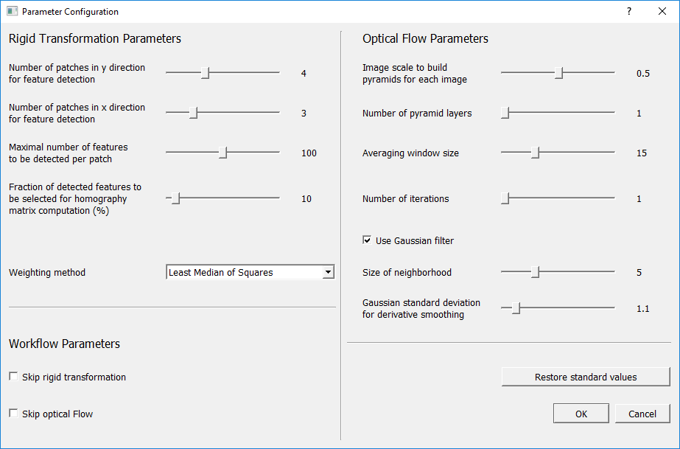

Parameters are organized in three sections:

* Under the heading “Rigid Transformation Parameters” the user controls the behavior of the first registration phase. If things go wrong, it is most likely in this phase. The [ORB algorithm](https://docs.opencv.org/3.0-beta/doc/py_tutorials/py_feature2d/py_orb/py_orb.html) identifies so-called keypoints in both images and tries to match the corresponding points with each other. The keypoint pairs are then used to compute the rigid transformation, including translation, rotation, (unisotropic) scaling and skew.  
  If the image contains areas with very prominent surface contrast (such as the moon’s terminator region) and ones with very low contrast (such as the moon’s limb areas), the risk is that keypoints are not distributed well across the image. In the example above, most likely they would all be located close to the terminator. In such a case, the mapping between the color and B/W images would become singular, and the result would be very inaccurate.  
  As a remedy, the program offers to split the image in a grid of rectangular patches. The numbers of these patches in y and x directions are input parameters. The keypoint detection algorithm works on each patch separately, so it is forced to look for keypoints everywhere. If the result is bad, it is a good idea to try again with a different grid size.  
  The user can specify the maximal number of keypoints per patch, and the fraction of “good” keypoints to be selected for computing the transformation.  
  In principal, the computation of the homography transformation requires four keypoints only, so typically the problem is over-determined. The solution, therefore, is computed as a best fit. For the fitting, the user can choose between two weighting methods. “Least median of Squares” usually gives satisfactory results.
* If everything works well, the rigid transformation should leave registration errors of a few pixels only. They are removed by the second phase which uses a “[dense optical flow](https://docs.opencv.org/3.4/d7/d8b/tutorial_py_lucas_kanade.html)” method. Several parameters can be modified to control this process. For a detailed explanation of those parameters, please refer to the OpenCV documentation.
* Two checkboxes can be used to skip one of the above registration phases. If the first phase is skipped, the color image must match the shape (pixel numbers) of the B/W image, and both images must be registered up to a few pixels already.

Detailed tooltips are provided for all parameters. They appear as soon as the user moves the mouse over a parameter description.

The button “Restore standard values” helps, when after experiments with different parameter settings the user wants to return to the (recommended) standard values.

### Starting the registration process

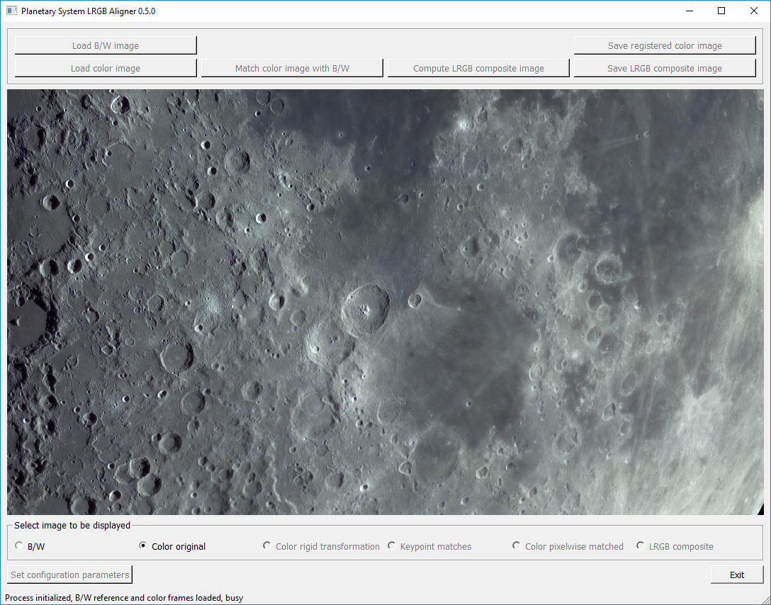

Once the input images are loaded and parameters are selected, the user starts the computation by pressing “Match color image with B/W”. Since the computation takes place in the background (as shown by the word “busy” in the status line), the user can still use the image viewer.

### Inspecting the registration quality

As soon as the results of the first registration phase become available, the corresponding radio buttons under the image viewer are activated. “Color rigid transformation” displays the image resulting from the first registration phase. By switching back and forth between this image and the B/W input, the registration accuracy of the first phase can be evaluated. The radio button “Keypoint matches” shows the two input images together with the keypoint pairs used in the homography computation. The user can check this illustration to troubleshoot problems with the registration accuracy.

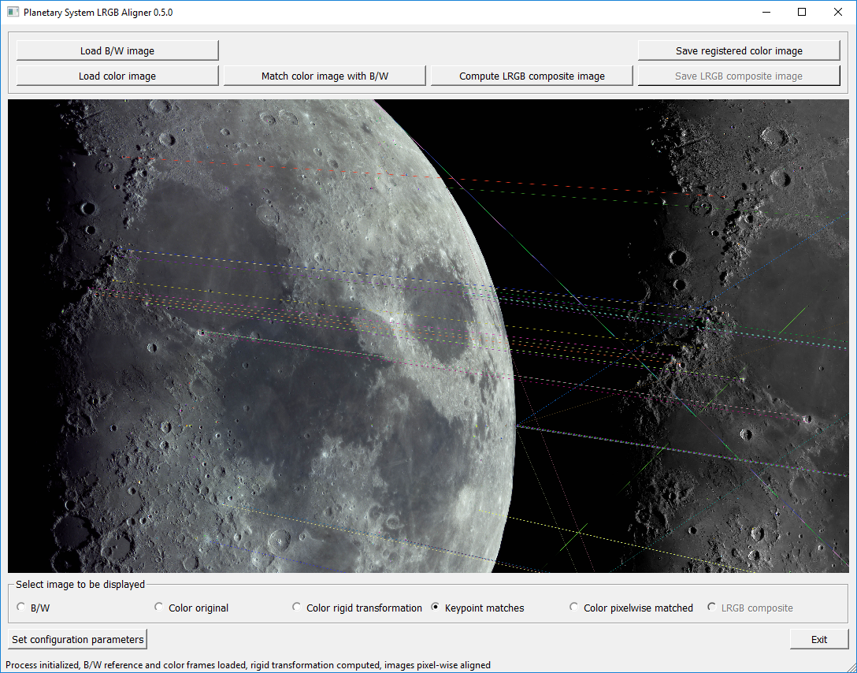

When the second phase is finished, the result of the optical flow algorithm can be inspected by pressing the “Color pixelwise matched” button.

After the registration computation is finished, the image viewer can be set to a high zoom rate to check the registration quality in various image locations. Here is an example view:

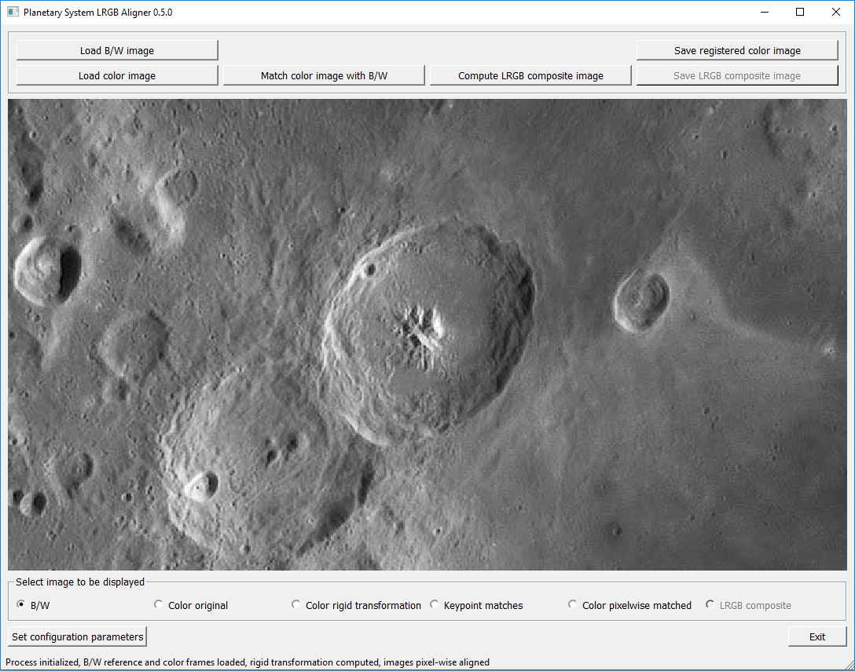

Original B/W image

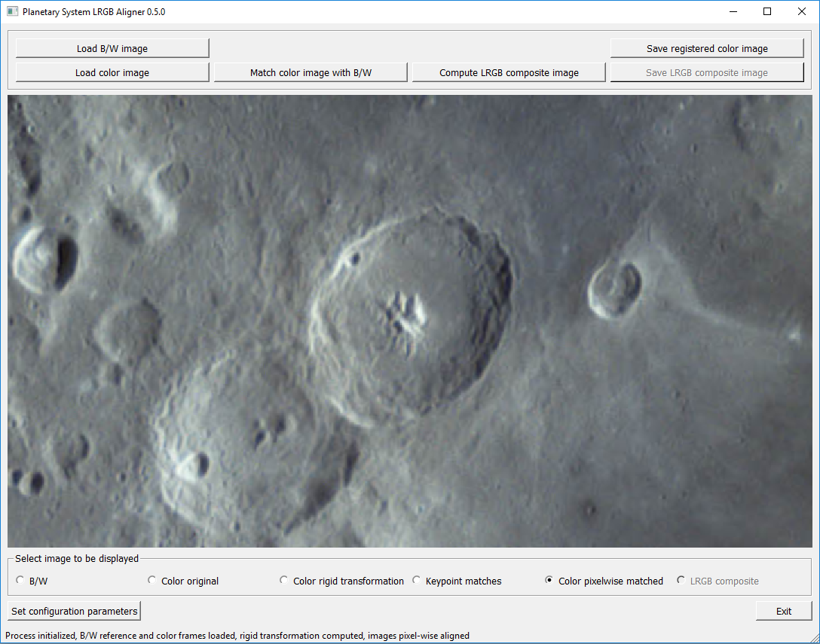

Color image after second registration phase

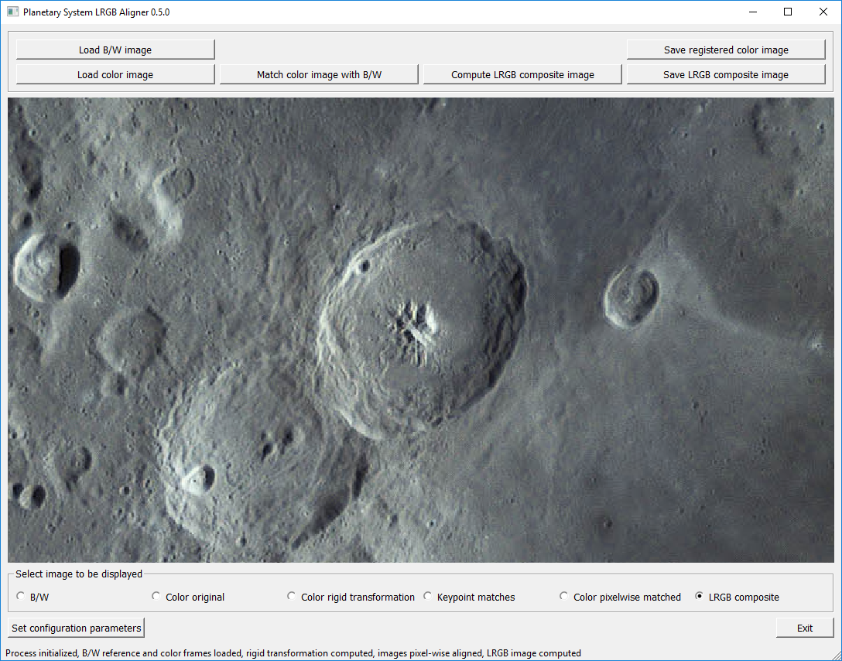

LRGB composite

Between images, surface features should stay in the same location.

### What if the registration failed?

If the rigid transformation shows a high degree of scaling anisotropy or does not preserve angles well, a warning appears as in this illustration.

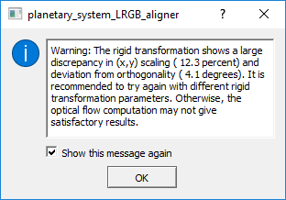

If this warning appears it is unlikely that the optical flow algorithm (second phase) can compensate the low precision of the first phase. It would, therefore, be a good idea to change parameters (e.g. increase the number of (x,y) patches) and try again.

What happens if the second registration phase continues after an unsuccessful rigid transformation can be seen in the illustration below.

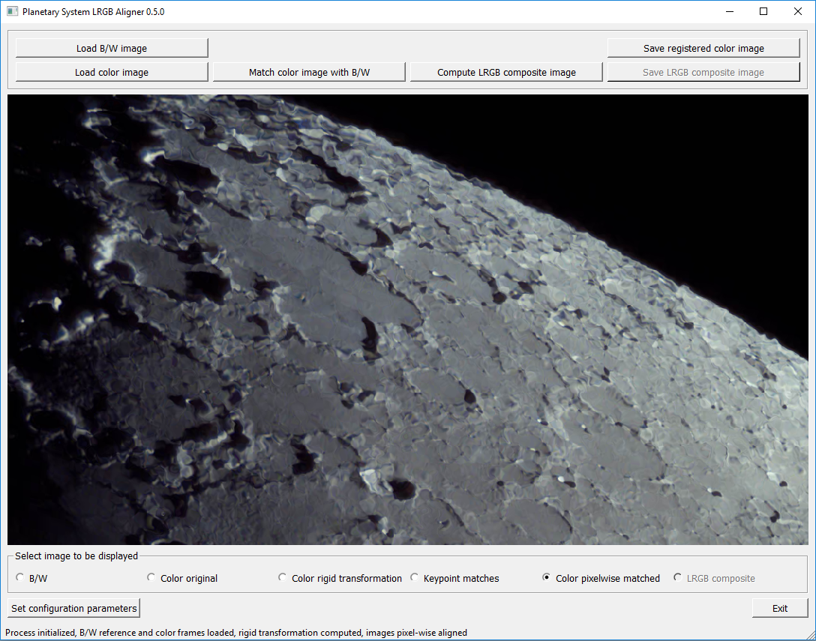

Crater rims and the limb contour are strongly distorted. Also, as can be checked by alternating between the radio buttons “B/W” and “Color pixelwise matched”, surface details jump back and forth, as a result of bad registration quality.

### LRGB image composition

Once the image registration has finished successfully, the user can press “Compute LRGB composite image” to combine the B/W and the transformed color images into an LRGB composite. The result can be accessed by pressing the radio button “LRGB composite”. This image should match the B/W image in resolution, and it should not display noticeable color artefacts.

### Saving the resulting images

The (pixelwise) registered color image can be saved to disk by pressing “Save registered color image”. It is recommended to use the uncompressed .tiff file format. This image file can be loaded together with the original B/W image in a program such as Adobe Photoshop for manual image processing.

If PlanetarySystemLRGBAligner was used to compute the LRGB composite automatically, the resulting image can be saved to disk by pressing “Save LRGB composite image”.